CS 3000

Spring 2020

Parker Evans

**Big Integer Assignment**

**Multiplication of Big Integers Runtime Graph.**

This assignment was to use the Big Integer Class to get data to create a graph showing the

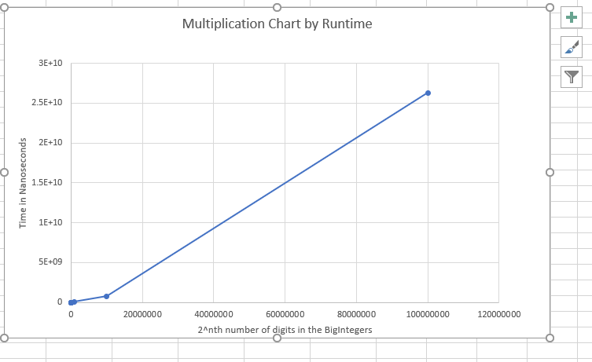Based on my numbers we get the following math to determine the Big O notation.

For an input of 1000 we get a runtime of 32460, so to try assuming linear runtime we see that this is not an upper bound since 2000 input is aveaged not at 2*32460 = 64,920 but at 119,800. However, it is a Quadratic or *O(n^2).*  See here 1000000 = 1000^2 has a runtime of 67,702,500 and we see that (32,460)^2 = 1,053,651,600 clearly an upper bound to it.

**Division of Big Integers Runtime Graphs**

This part of the assignment uses the similar analysis of Big Integers; however, it analyzes the runtimes of dividing the two Big Integers instead of multiplying them.

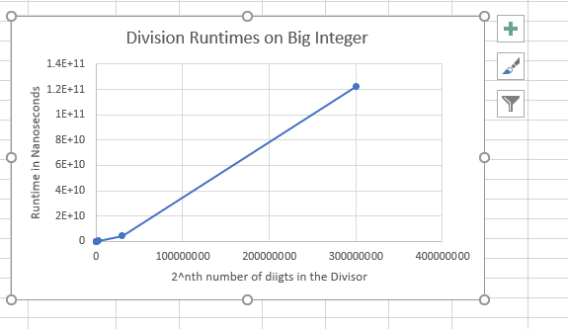

I found a similar result on the runtimes; it is clearly by its shape and runtimes that it is not *O(n),*  and when comparing the runtimes we see that it is also *O(n^2)*, as n^2 is an upper bound, and it has a similar shape to a quadratic function.